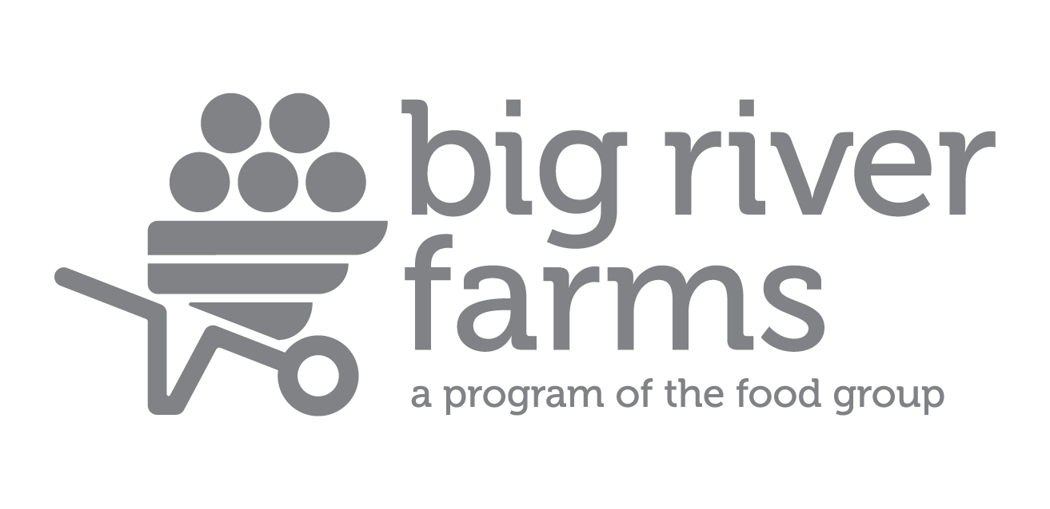
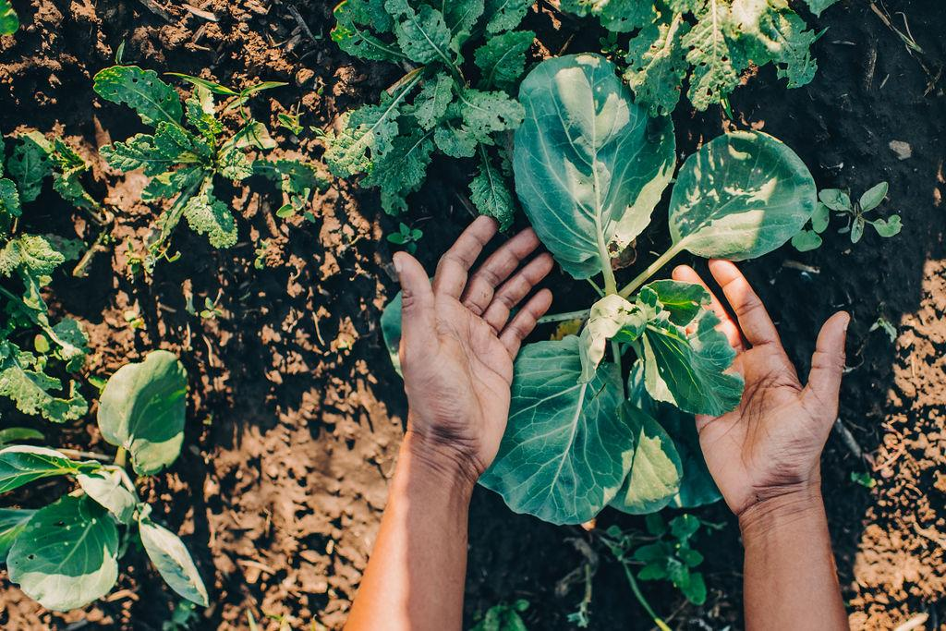

Incubator Program

Program Details:
The Big River Farms Incubator Program supports emerging farmers by providing affordable land access, farm infrastructure, business development and training resources. To participate in the Incubator program participants will either need to complete the Big River Farms Grower Training Program or have equivalent farming experience working on other farms or farming on their own for 2-4 years in Minnesota or a similar growing climate. It is designed to serve immigrant, limited resource, and historically underserved individuals.

Participants in this program should have experience with the following skills:

-Creating seeding and crop plans for the season
-Creating a fertility plan
-Setting up irrigation for your field
-Preparing your field for transplanting/direct seeding
-Routine weed management
-Familiarity with food safety practices
-Harvest and post-harvest practices
-Selling to markets

Participants will be responsible for their own cover cropping, fertility management, tractor operations, Organic Certification, and market plans. Most incubator farmers spend 3-5 years on average at Big River Farms before transitioning to their own farm or other opportunities.
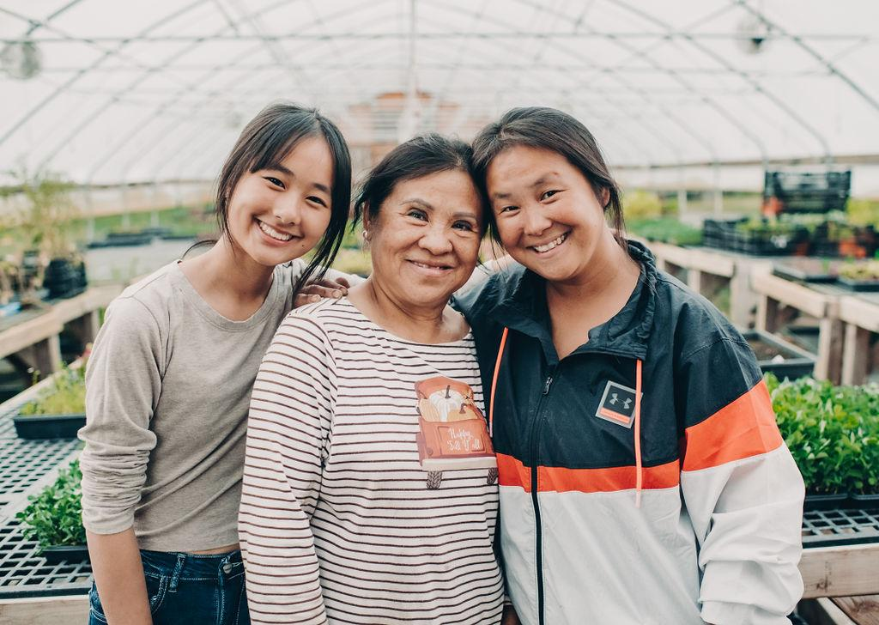

What will I learn?

Classes & Workshops: As a participant in the Incubator Farm Program, you have access to select Big River Farms training courses & curriculum
Business Development Support: Business planning classes in the winter and then work 1:1 with a staff member or consultant on developing your business plan
Networks: Connection to mentors and resources needed to meet your business and farmland ownership goals.
Farm Visits: Field days at other farms covering more advanced production topics to enhance your knowledge.
One to One support: Staff and farmer mentors are available for additional technical assistance as needed throughout the year, including in-field help for farmers at Big River Farms.

What’s included?
Land for Rent: Growers are eligible for ½-2 acres of field space, depending on previous farming experience. After their first year, additional land can be rented. Additional land will be rented based on field assessment scores, program involvement, and business planning.
Greenhouse Space: Participants will be guaranteed 3 tables in the heated greenhouse each season. This space can be used from early March to late October. Additional tables can be rented as they are available.
Walk-in Cooler: Participants renting ½
acres will be guaranteed a ½ pallet of cooler space, renting ¾
acres or more you will be guaranteed 1 pallet. If additional pallets are available, they will be rented out.
Equipment: Access to basic hand tools, push seeders, hand weeding tools at no additional charge. Participants can hire Food group staff to perform tractor work such as rototilling, mowing, chisel plowing, and discing.
Irrigation- Access to in field irrigation is available from May 15-October 15. Participants have to provide their own irrigation equipment (hoses, sprinklers, drip tape etc.) Access to an irrigation point will be within 150 feet of your field. Irrigation connections may be shared with other participants.
Wash and Pack shed- Growers have access to the wash and pack area. Growers will need to provide their own harvest supplies, such as harvest totes, waxed boxes, plastic bags, rubber bands, etc. Big River Farms will provide cleaning and sanitizing supplies.
Storage- Participants will have 1 pallet of inside storage space at the farm for tools and miscellaneous supplies. Food safe storage for wax boxes can be made available at the participants request.

How much does it cost?
Land | $400 per Acre
Infrastructure | $300 per year

How do I apply?

Step 1: Contact Big River Farms Programs: bigriverfarms@thefoodgroupmn.org or call the farm office at 651-433-3676 to inquire about joining our program.
Step 2: Attend an open house to go over the program details, ask questions, and tour the farm. Applications will be available.
Step 3: Turn in your application to Big River Farms by November 30. You may turn it in in-person, email it to bigriverfarms@thefoodgroupmn.org or mail it to Big River Farms, 14220-B Ostlund Trail N, Marine on St Croix, MN 55047.
Step 4: Our staff will follow up with you to determine if the program is a good fit and with information about what comes next. Decisions on program acceptance will be shared no later than December 30 for applications received on time.

For more information…
Big River Farms is a program of The Food Group, a nonprofit organization with the mission, “Fighting hunger. Nourishing our community.” Learn more about Big River Farms and the other programs of The Food Group online at:

www.bigriverfarms.org | www.thefoodgroupmn.org

