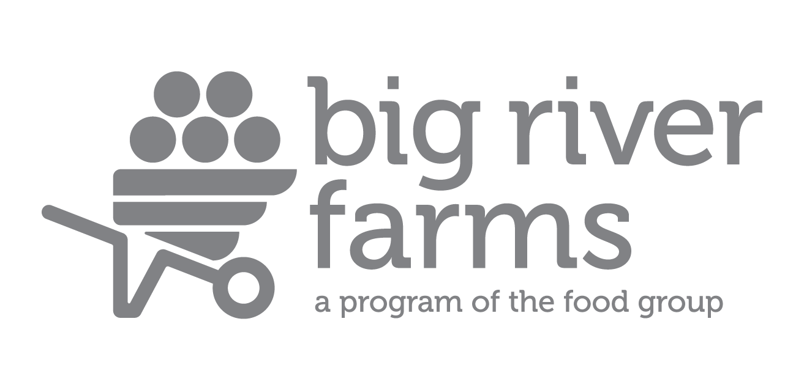

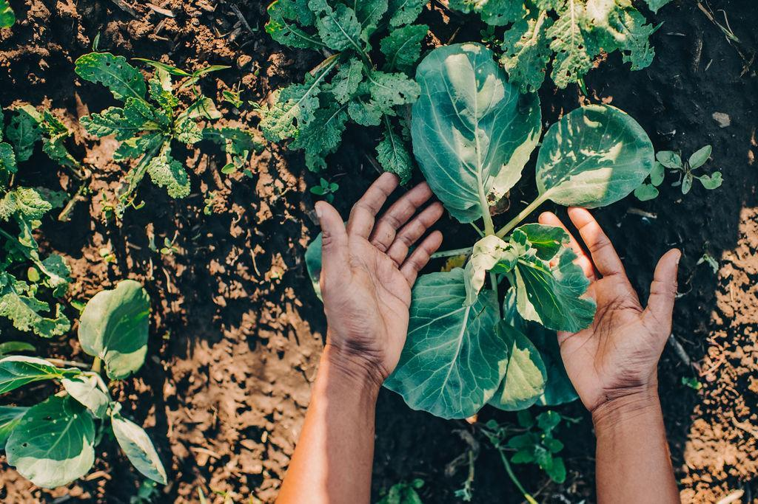

Grower Training Program

Grower Training Program

Program Details
The Big River Farms Grower Training Program is a 3-year program that focuses on training participants to cultivate crops for organic production and develop the basics for launching a farming business or to grow food for your community. It is designed to serve immigrant, limited resource, and historically underserved individuals.

The program operates year-round with winter coursework, seasonal land-based training and in-field workshops. Winter classes are held in the Twin Cities to learn and plan for the growing season ahead. Starting in April, the education program transitions to Big River Farms, located 30 miles from the Twin Cities in Marine on St. Croix. This is where participants are able to put what they've learned in class and in meetings to practice on their own plot of land. Throughout the season, skill sessions, in-field classes and field trips to other farms are key in demonstrating important techniques and practices. Unique to this program is the one-on-one assistance available throughout the season, both in-field technical assistance and market planning & support.

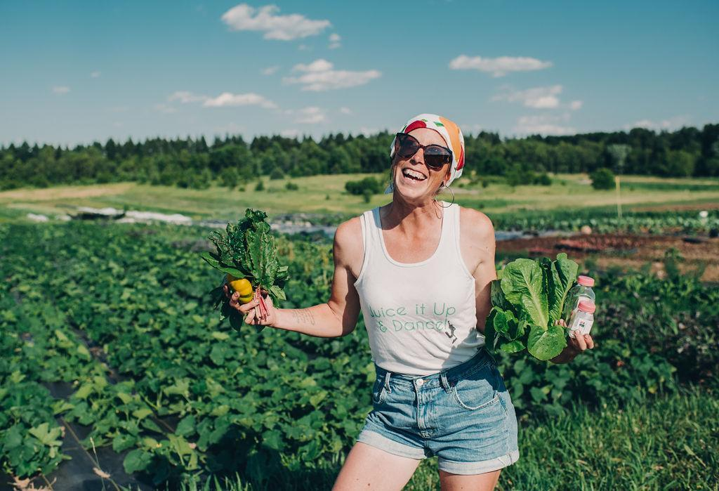
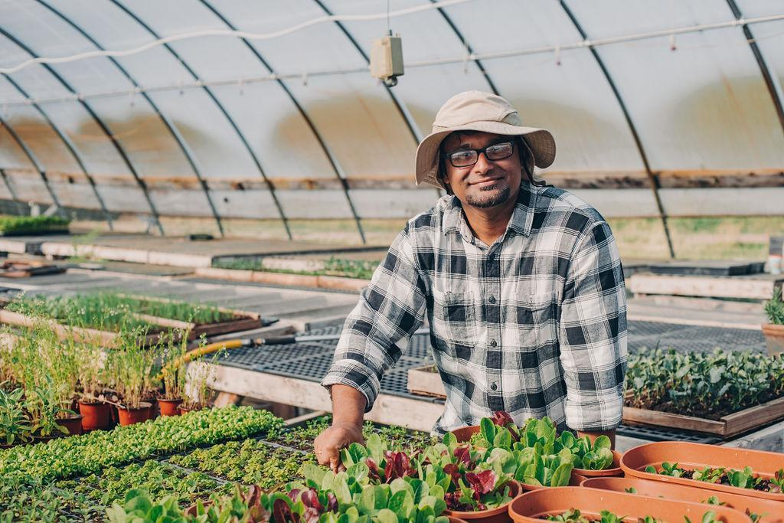

What will I learn?

Each training level has a unique focus. After completion of the program, you will receive a Grower Training Certificate of Completion.

Level 1 - Starting your Farm Plot
Level 2 - Starting your Market
Level 3 – Starting a Business Plan
Topics covered in trainings and classes include:

- Organic Crop Management
  - Crop planning
  - Direct seeding and transplanting
  - Crop families and profiles
  - Greenhouse Production
  - Harvest & Post-Harvest handling

- Pest, Weed, and Disease Management
  - Pest and disease management
  - Organic production methods
  - Soil Health and Fertility
  - Weed control best practices

- Business & Market Development
- Production and Financial Recordkeeping
  - Goal Setting
  - Business Plan creation
  - Selling to different markets
  - Market Planning

- Improving Production Efficiencies
  - Tool and equipment training

Time Commitment:

Program Commitment: January - March: 5-7 hours per week - weekly trainings in the metro area occurring on weekday evenings and weekend days; farm season planning and preparation. April-October: 15-20 hours per week - field work & in-field trainings each week occurring on evenings and weekends.

*Estimates do not include communications & transportation to the farm

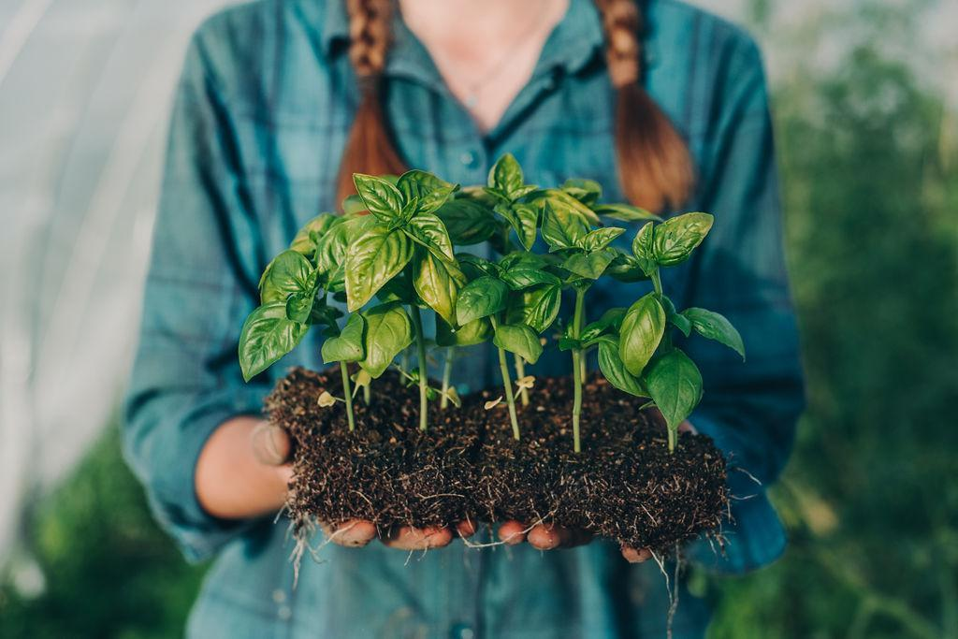
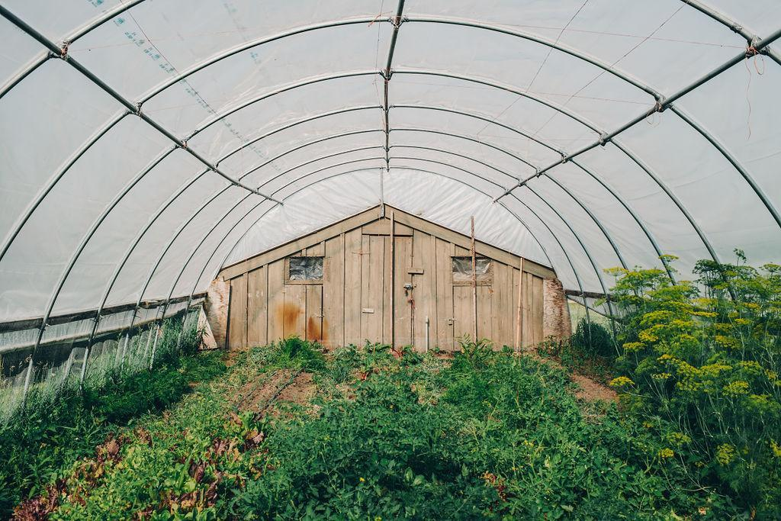
What is included?

Grower Training: Develop and execute a field plan for production under the support and mentorship of Big River Farms staff and mentors. Each participant will learn the basics of growing food crops organically, how to maintain a plot for good soil, disease and weed management. Growers develop the skills they need to grow food for market and learn how to transform their goals into a small farm business.

One-on-one Support: Each grower receives tailored 1:1 support with farm staff & mentors. Training support focuses on goal setting, seasonal check-ins, technical assistance, planning support and more. Big River Farms staff specialists are available onsite for ongoing assistance, in addition to leading classes, skill sessions and other in field training.

Classes & Farm Tours: Winter training courses take place January-March, to prepare growers for the season ahead. In field hands-on trainings and farm tours run April-October at Big River Farms or guest sites. They are taught by program staff, local farmers, and specialists in the field. During the growing season training consists of classes, field days, hands-on technical support in the field and site visits to other area farms.

Land: Growers entering the program start growing on a level one plot. This plot is managed independently by the participating grower at Big River Farms. Farmland at Big River Farms is certified organic. They maintain this size in Level 2, allowing them to hone their skills in a manageable space and spend time marketing their crops. By Level 3, growers can expand their land, provided they've effectively managed their initial plot.

Infrastructure: Shared amenities are available for growers, including fencing, water, greenhouse, pack shed, walk-in cooler, on-farm storage, tractor work, shared tools/equipment and utilities.

How much does it cost?
The Grower Training Program fee for participants is $350
Scholarships may be available

Included in this fee, each grower receives a Farmer Starter Kit with their plot, this includes supplies such as: compost, seed starting mix, drip irrigation and landscape fabric.

What other costs should I expect?
- Seeds
- Transportation to and from the farm
- Additional supplies you choose to purchase in addition to the Farmer Starter Kit

Is this program for me? Yes, if:

- You would like to learn more about growing food using organic methods
- You are interested in learning more about developing a farming business
- You identify with a group that is historically under-represented in farming (immigrant, refugee, person of color, women, LGBTQ, veteran, low-income, or other)
- You have access to the resources needed to participate (reliable transportation, supply cost, time to dedicate to education classes and field work)
- You are interested and engaged in working with a diverse community of staff, mentors and growers.

Continuing Education: Levels 2 & 3
Upon completion of Level 1, growers will continue to focus on crop production and begin focusing on marketing crops and accessing markets. As participants continue in the program, the learning is focused on the skills needed to manage a farm business independently. Big River Farms will provide support in accessing markets and other needed resources.

Field plots can be expanded as you continue in the program depending on field assessments, program involvement, farm goals and land availability. Program fees for Levels 2-3 will include land & infrastructure fees as well as soil starting mix & field compost. Additional supplies needed for purchase to expand are not covered as they are provided in year 1 for a first-year plot.

The application process will help growers determine what level they start in the program, as some may have prior experience farming.

How do I apply?

Contact Big River Farms Programs: bigriverfarms@thefoodgroupmn.org or call the farm office at 651-433-3676 to inquire about joining our program.
Step 2: Attend an open house to go over the program details, ask questions, and tour the farm. Applications will be available.
Step 3: Turn in your application to Big River Farms by November 30. You may turn it in in-person, email it to bigriverfarms@thefoodgroupmn.org or mail it to Big River Farms, 14220-B Ostlund Trail N, Marine on St Croix, MN 55047.
Step 4: Our staff will follow up with you to determine if the program is a good fit and with information about what comes next. Decisions on program acceptance will be shared no later than December 30 for applications received on time.

For more information…
Big River Farms is a program of The Food Group, a nonprofit organization with the mission, “Fighting hunger. Nourishing our community.” Learn more about Big River Farms and the other programs of The Food Group online at:

www.bigriverfarms.org | www.thefoodgroupmn.org

